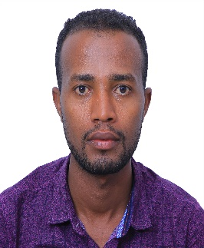
Title: Small Satellite Electro-Optical System (EOS) Technological and Commercial Expansion
Author: Dinaol Z. Gadisa Affiliate: 1. ASCL, Department Aerospace engineering, Korean Advanced Institute of Science and Technology (KAIST), Daejeon, 34141, Republic of Korea zdinaol2@gmail.com| gdina@kaist.ac.kr
Dinaol Gadisa is a research affiliate in the Aerospace System and Control Lab at the KAIST. He received a BSc in Physics from the University of Adama Science and
Technology in 2014, PGD in satellite communication from the ARCSSTEE in 2018, and Master’s degree in aerospace engineering from KAIST in 2023. Prior to joining KAIST, Gadisa held positions at Ethiopian Space Science and Technology Institute and Ethiopian Airlines. Gadisa’s research interest include aerospace propulsion (electric), space system optimization, spacecraft payload design, and space policy.

